SF THEORY

Gabrielle Sandbothe
11/23/19

Image 1, Verse 2

Not going to beat a dead horse to death. Image has clues to SF all through it. The key item in the image is the “green beans” found in the rose. Green beans, string beans, pole beans.
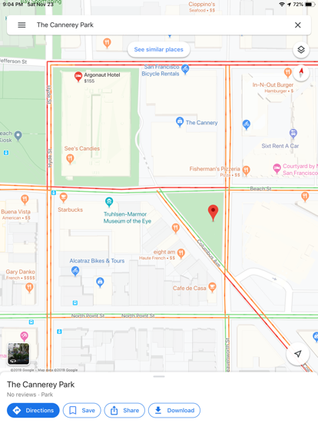
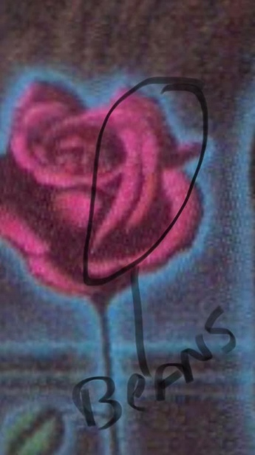

This whole theory is based on these beans, starting with The Cannery.
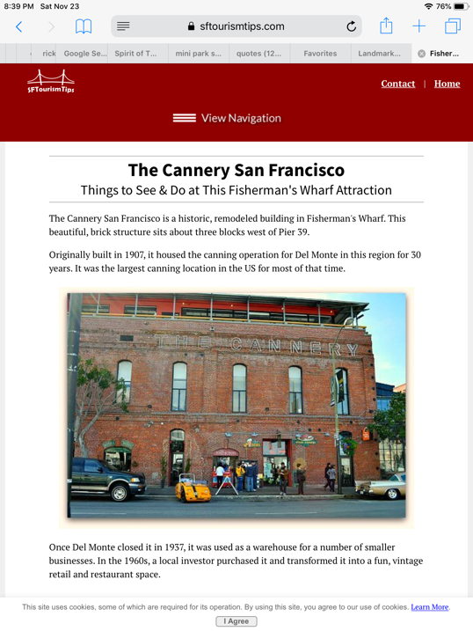
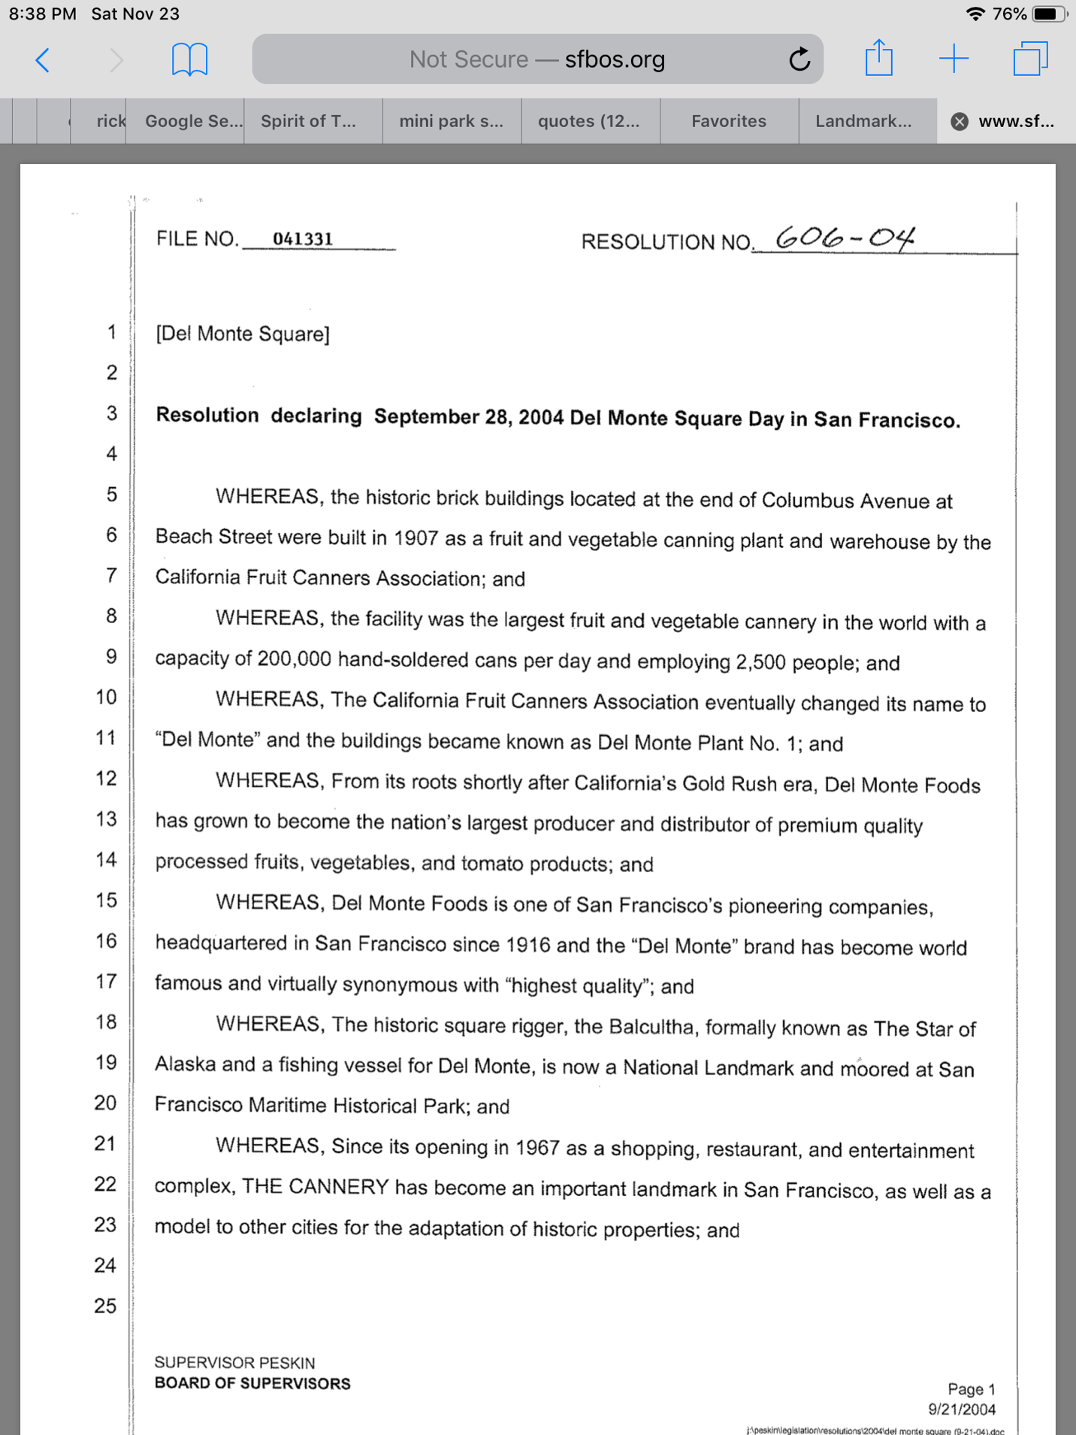

The Cannery, also known as Del Monte Plant No 1, also owned the Haslett Warehouse, now known as the Argonaut Hotel.
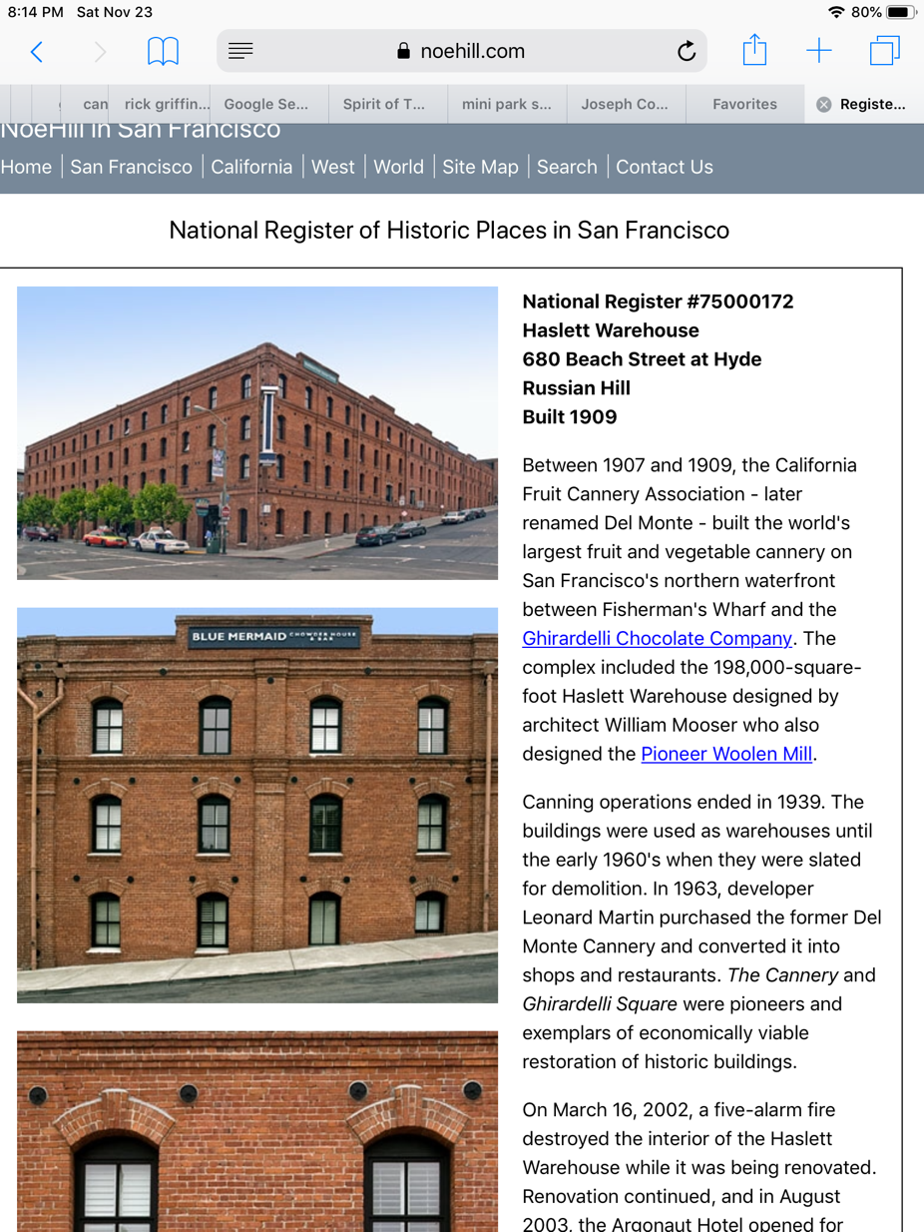

“Shortly after World War II, Haslett Warehouse was a mortuary. Bodies of deceased Chinese bound for burial in their homeland rested in the warehouse until brokers determined that a full cargo load could depart for China.

The warehouse was also used to store imported automobiles, tires and, until 1948, numerous items from China. [Difficult to believe that there was a time, not too long ago, when the United States did not trade with Communist China!]” – from Google.

For those who believe in the Field Guide to Fair Folk having clues to the casque whereabouts (Boston and Team Spirits is a prime example of this), the “Giant”, which can be found on Page 202, talks of Jolly Green Giant, a competitor to Del Monte.
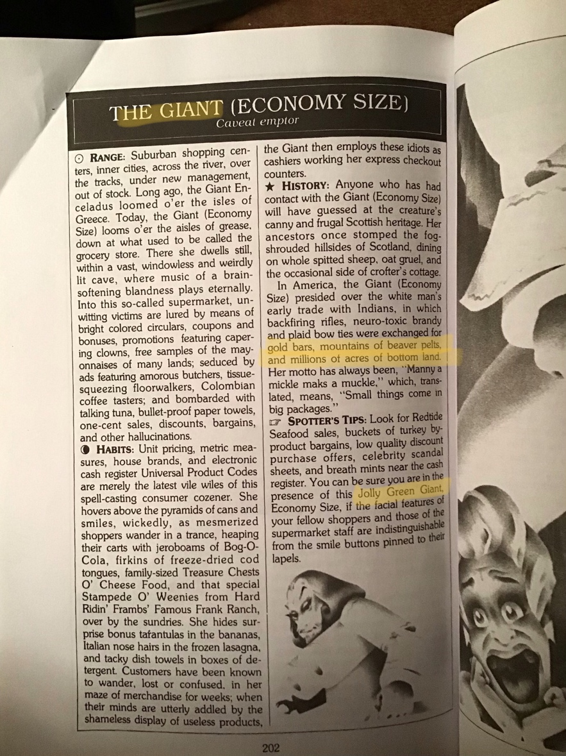

Tying it all up, the verse lines and their possible answers are:

At stone wall’s door Hallest Warehouse (a doorway is bricked up)
Obviously brick isn’t stone but I think that’s a play on words
(Hyde & Jefferson)

The air smells sweet Figuratively speaking, it was a Cannery known for peaches, other
Fruits and vegetables.

Not far away Within sight

High posts are three The Balcultha is connected to Del Monte (see earlier photo)

Education and Justice From site, this clue should be visible (possibly Polk)

Sounds from the sky From Hyde St, the speakers at Aquatic Park should be in sight

Near ace is high Plant No 1 is painted on top of the wall (off Beach)
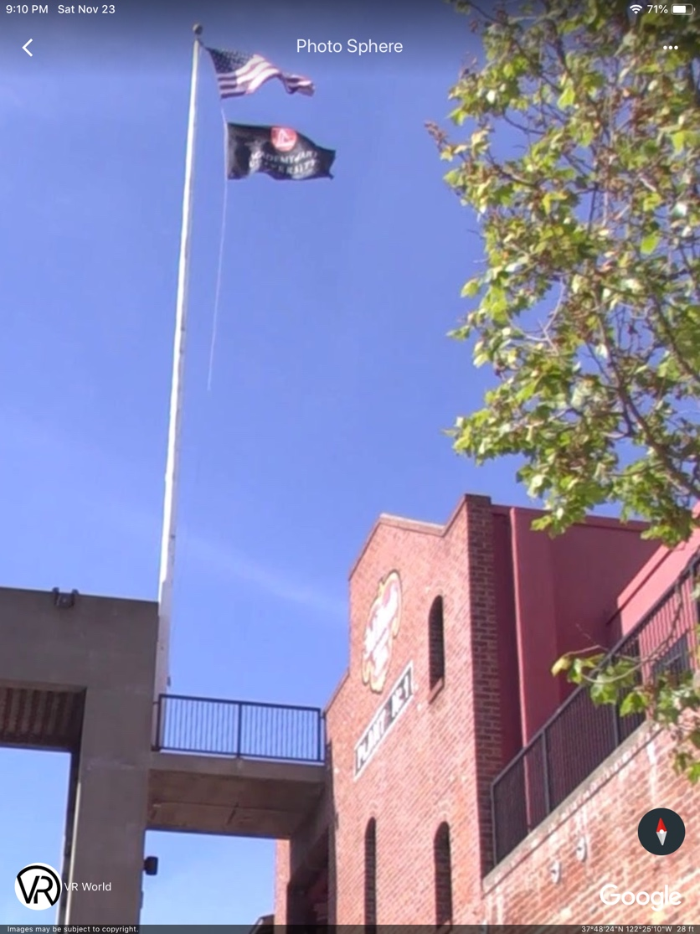

Running north, but first across North St, across Columbus (first across the Atlantic Columbus)

In Jewel’s direction There is a Holiday In across from
Is an object Joseph Conrad Mini Park
Of Twain’s attention Also called The Cannery Park (Hotel is the object)

Giant pole Reference to green beans/Cannery that were canned or J Conrad
Giant Step see photo

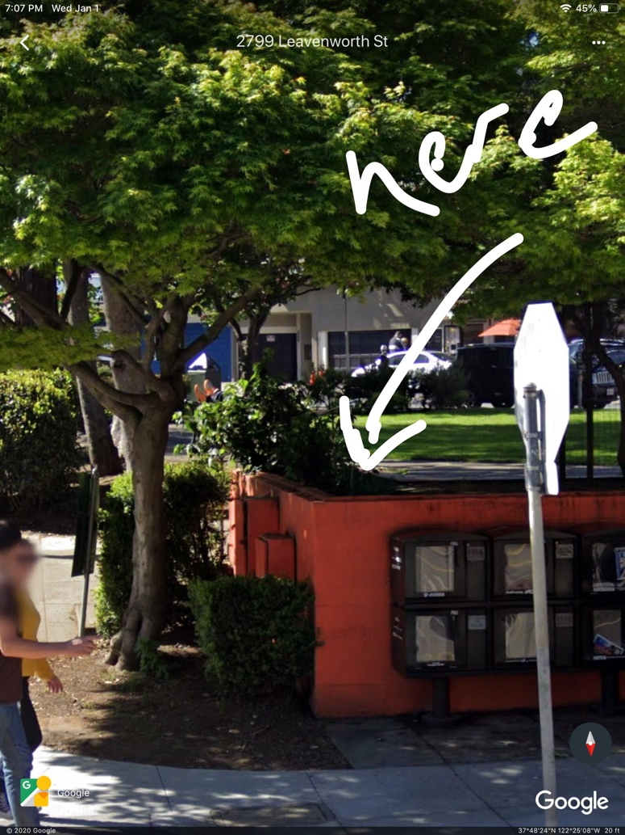

Joseph Conrad, famous author of maritime themed novels.
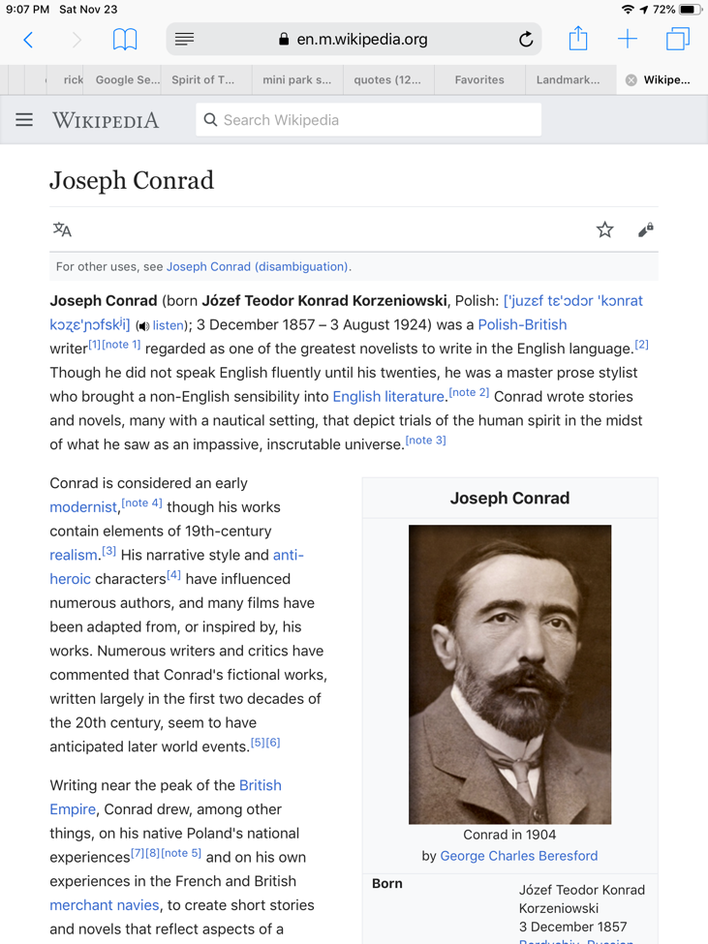

Conrad has been compared to Mark Twain due to both of their love of the sea and rivers.
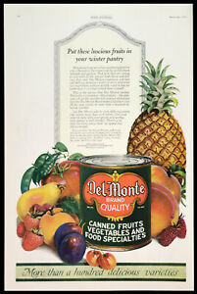
1920s with green beans shown n the left. I believe the “fruit archway” at The Cannery, should also have green beans on it.
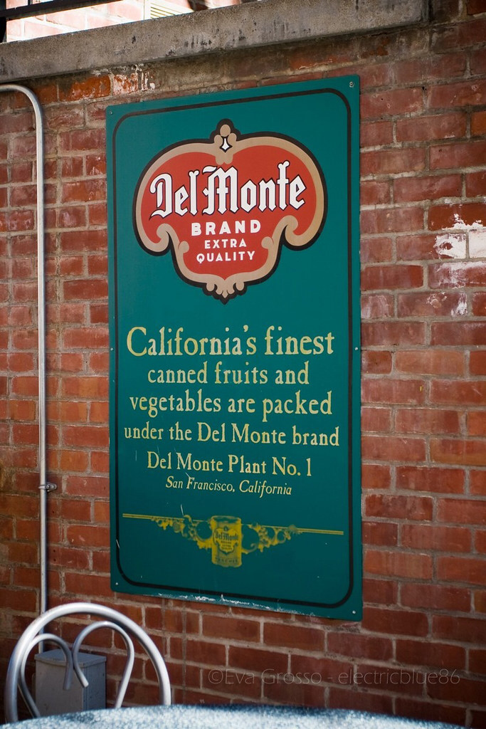

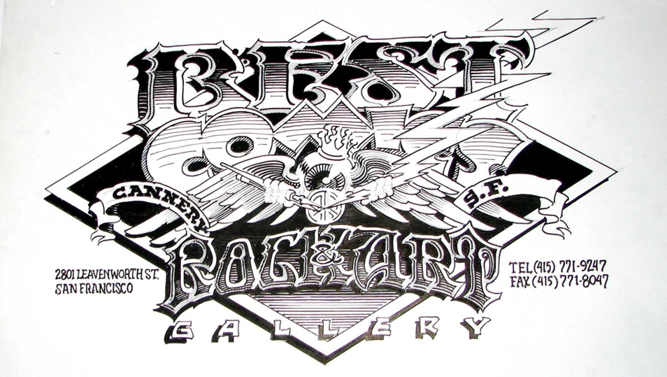
Tasty tidbit … The Cannery was home to a gallery of Rick Griffin’s art. He won the Inkpot award in 1977, one year after Byron had won it. I have to think that maybe Byron and him were friends and maybe he was even there for the opening, knowing that one of his treasures was close by.
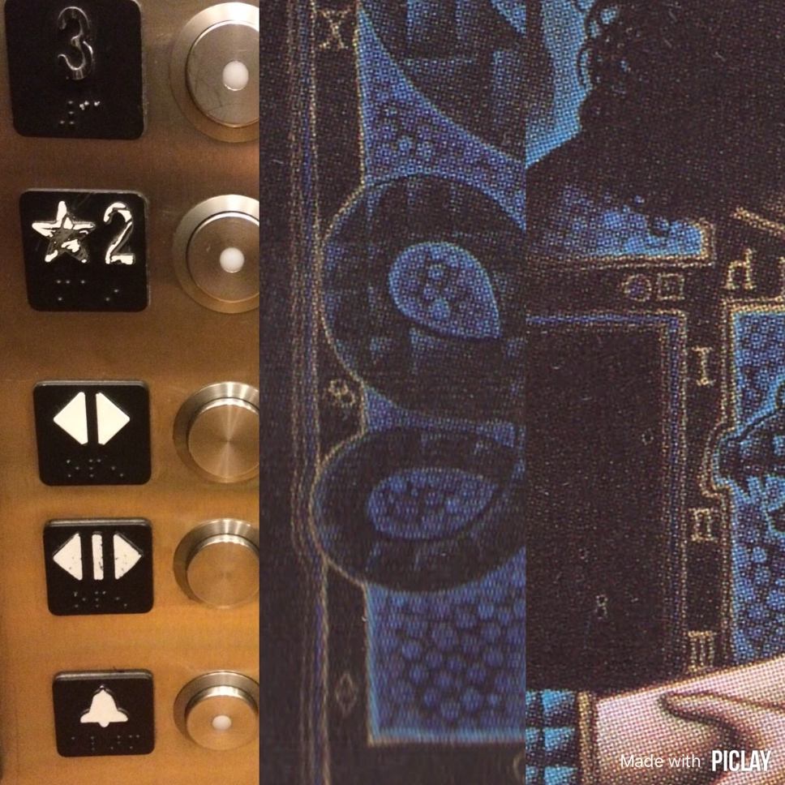
Glass Otis Elevator at the Cannery has control buttons shown in the dress. Another clue that this is the right area.
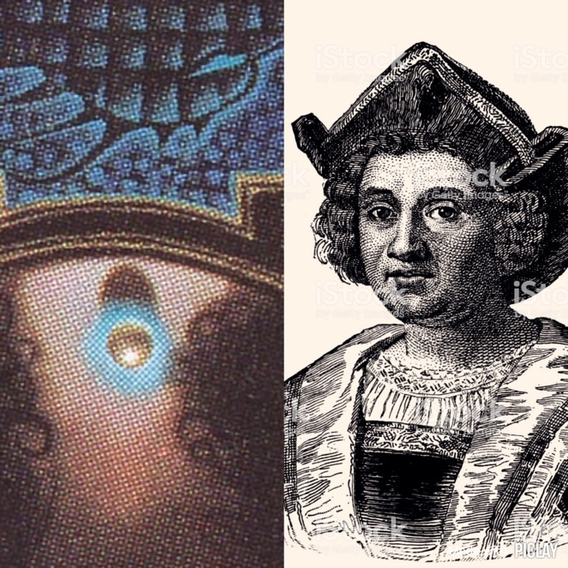

Columbus St.

